**INFORMATION SYSTEM INTEGRATION AND PRACTICE**

- PROJECT REPORT -

**CottonKing Confection System**

**Group Member**

Ahmad Fahri (2018130175)

Andhika Prasetyo (2018130173)

Michael (2018130172)

**DONGGUK UNIVERSITY**

**2018. 06. 16**

**Introduction To CottonKing System**

CottonKing Confection Business System is a system created for CottonKing Confection using PHP, HTML, and using MySQL Database. The system is created to support the CottonKing Business specializing in clothing confection, this system will be use by the customers to reach CottonKing and for the Admin or the manager to easily manage the business and the orders.

**Purpose**

The purpose of the system is to make it easier for the customers to purchase products from CottonKing Confection and making it easier for customers to contact the business. From the company side, this system is used to ease the orders managing and stock managing process.

**Use Case**

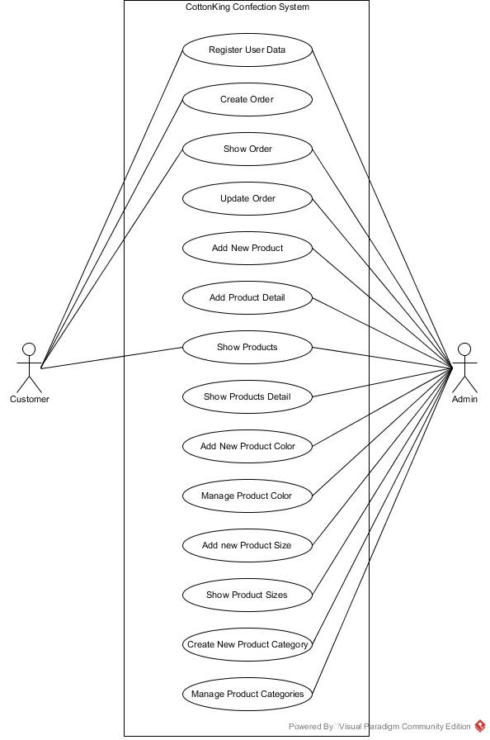This is the use case for CottonKing System

The CottonKing Use Case representing the functions or features for each of the actors in the system, in this case the actors they are customers and admin. Both of them has different features in the system but sometimes they share the same features, only with a different permissions or different views.

**ERD Diagram**

This is the ERD (Entity Relationship Diagram) for CottonKing Confection System

A close up of a piece of paper

Description generated with high confidence

The ERD above shows the representation of the database relations in the CottonKing Confection system. These are the important entities within the CottonKing Confection System, the entities are admin, productName, productCategory, customer, productDetail, size, color, and chart. Each of the entities has their own attributes and primary key as identificator and each of the entities has their own relations with other entities to form a complete database.

**User Interface User**

* **Home Page**

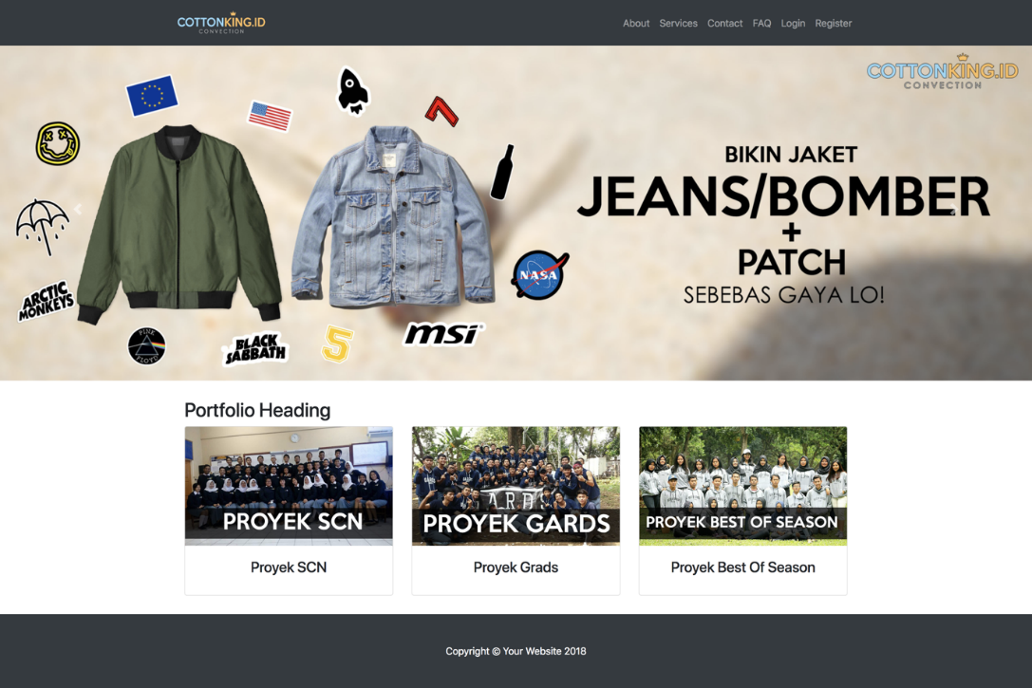

The first page or UI that the customers will see when they open the website. In this page customer will see the advertisements in form of banners and the portfolio of the business from the previous projects.

* **User Login**

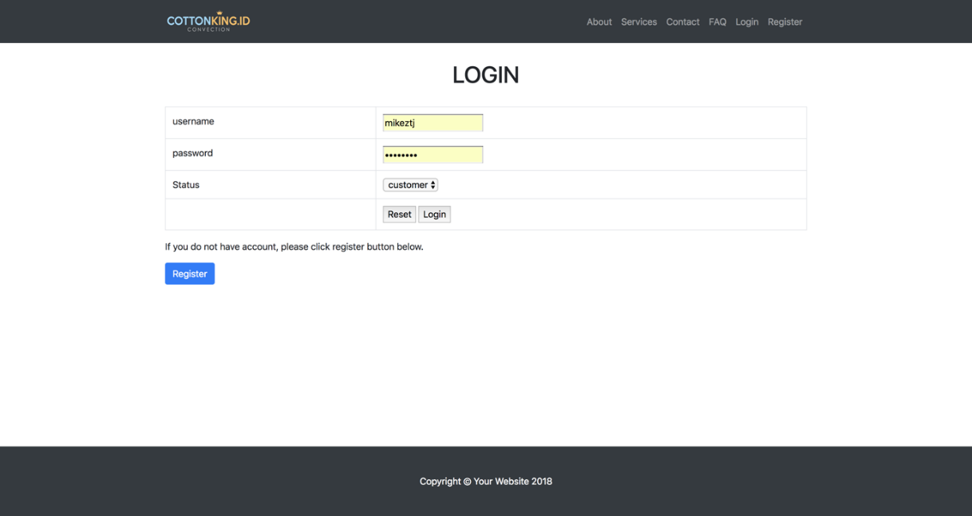

In User Login interface users or customers are able to log themselves into the system by acquiring their data. The data that is needed to be able to login to the system is the customers username, password, and the status or login type (to choose between login as customer or admin). In order for the login to be successful customer need to register themselves first in the register user page or UI, this can be done by clicking on the blue “Register” button. If the data is correct customers can click on “Login” button to continue using the website services, but if the data is incorrect customer can click on “Reset” to clear all the text fields.

* **User Register**

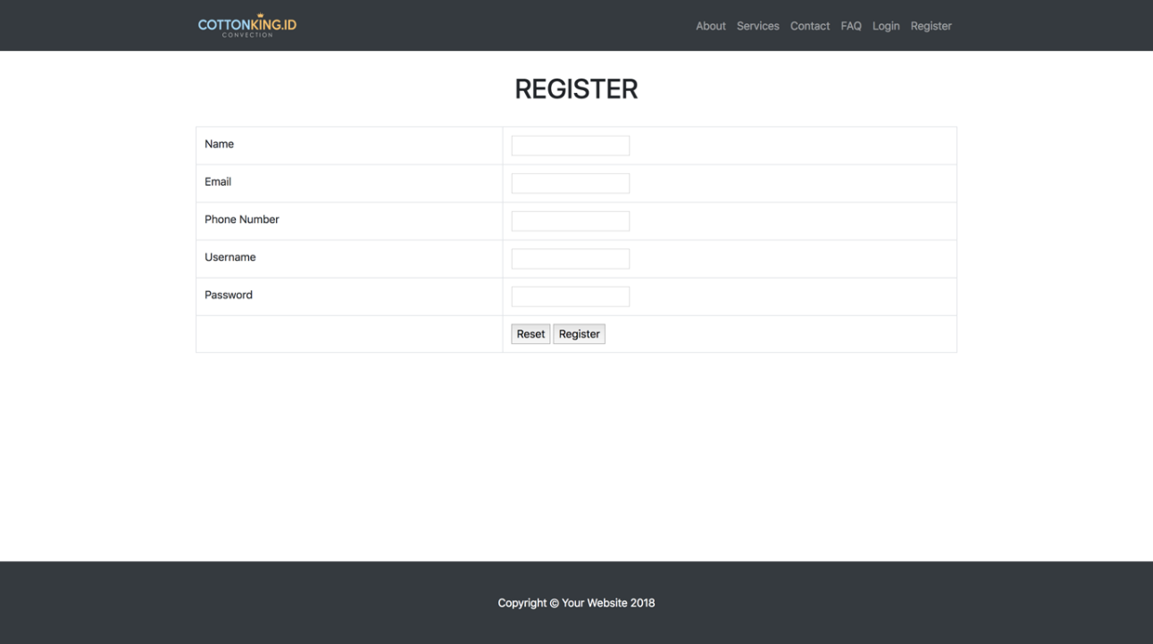

In this part of the UI user or customers are able to register themselves for them to be able to login into the system. Customers are only required to fill in the text fields with their data such as Name, Email, Phone Number, Username for login, and password. If the customers finished filling out the text fields they can choose between “Reset” to clear all the text fields if there’s any mistakes or click on “Register” to continue registering their data into the system.

* **Service**

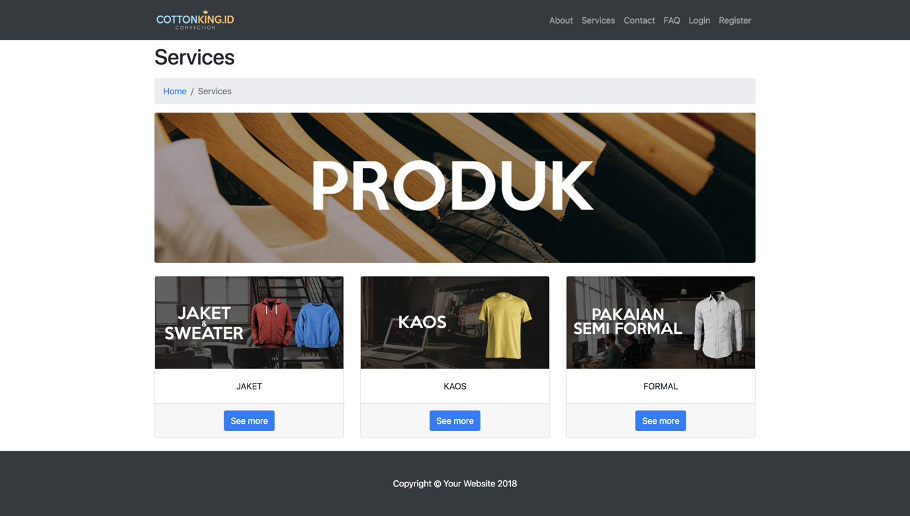

After Login and Register customers can start buying products by choosing which products categories that they wanted first. After they found the categories that they wanted they only need to click on the “See more” blue button under the categories to open the products list on the chosen categories.

* **Service After Login**

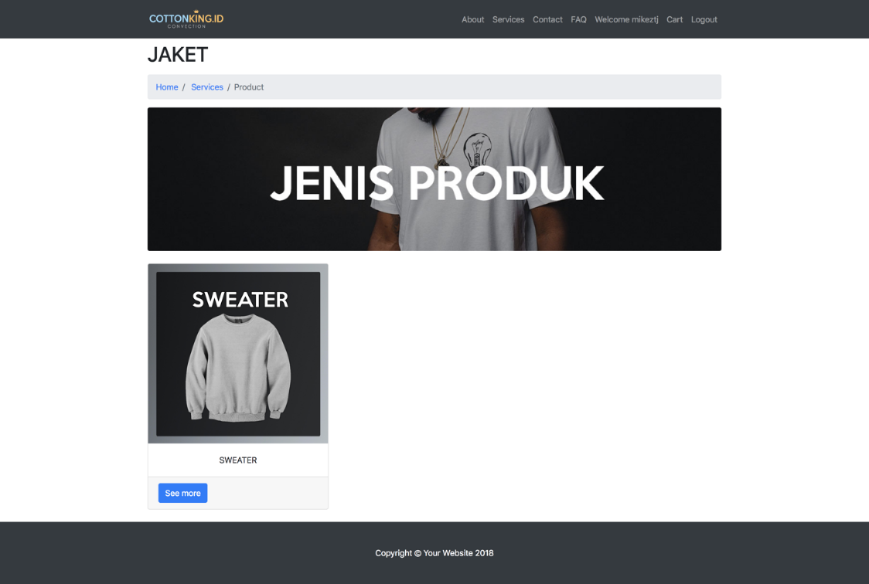

If the customers is already logged in to the systems customers will see this page or UI where the blue “See More” button to order the product is available. If the consumers want to buy the product customers just only need to click on the blue ”See More” Button.

* **Service Before Login**

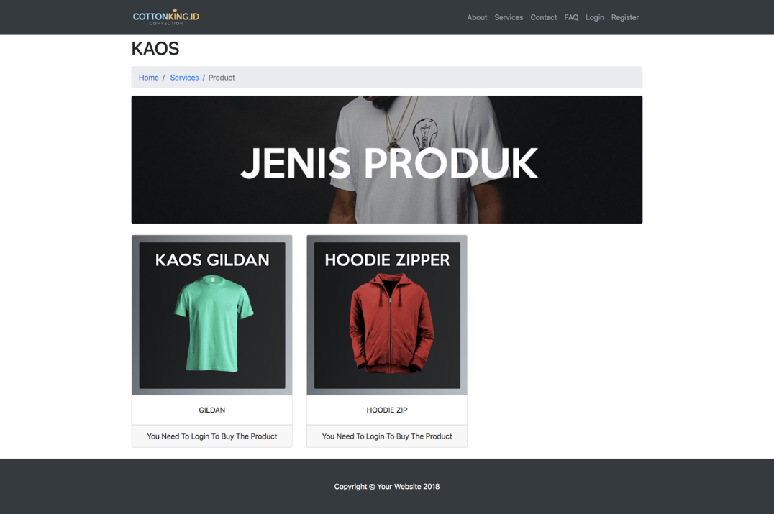

If the customers haven’t login into the system the product page will look like the above examples where the blue “See more” button is unavailable and there will be a “You need to Login to buy the product” message.

* **Order Page**

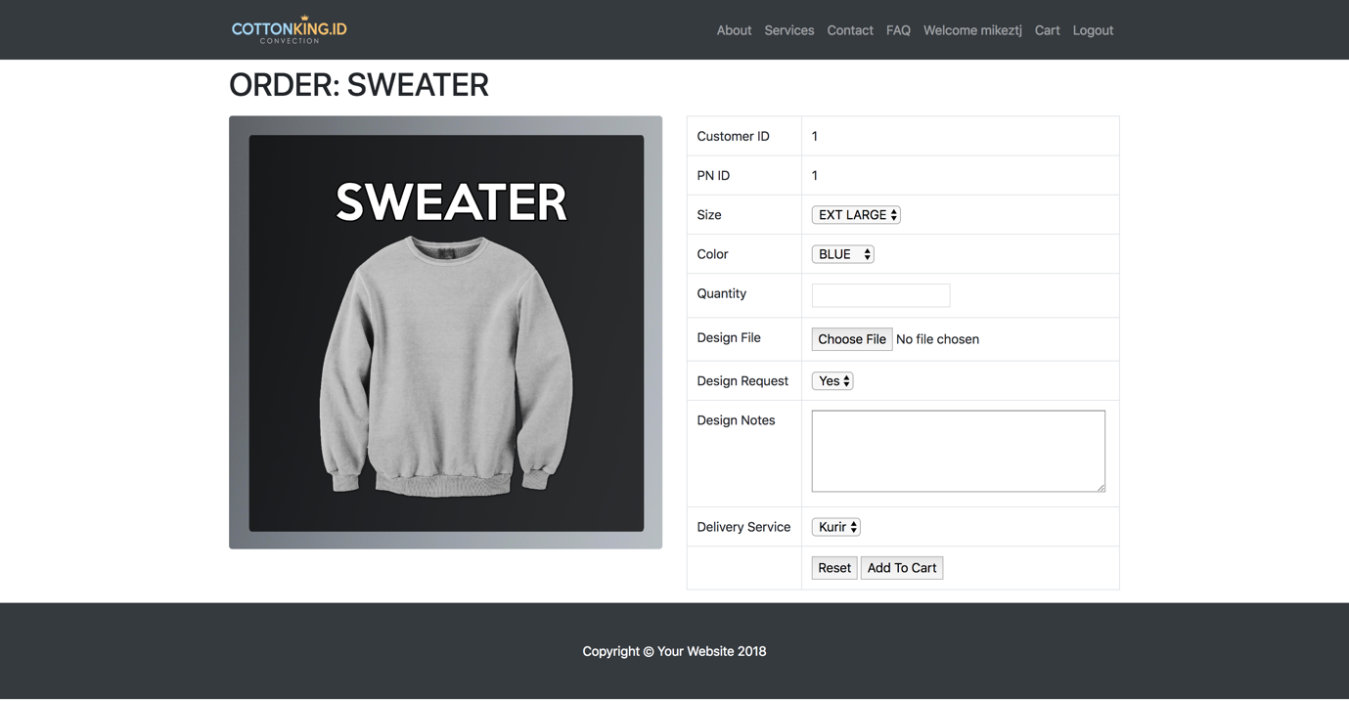

The Order page or UI is where the customers is already logged in into the system and customers already went trough the product selecting process. In the order page customers will fill out the order data required for the purchase. The data are Size, Colour, Quantity, Design File (Optional), Design Request, Design Notes (Optional), and Delivery Services types. After a customer finish filling out the data they only need to click on the “Add to chart” button to finish the ordering process.

* **Cart**

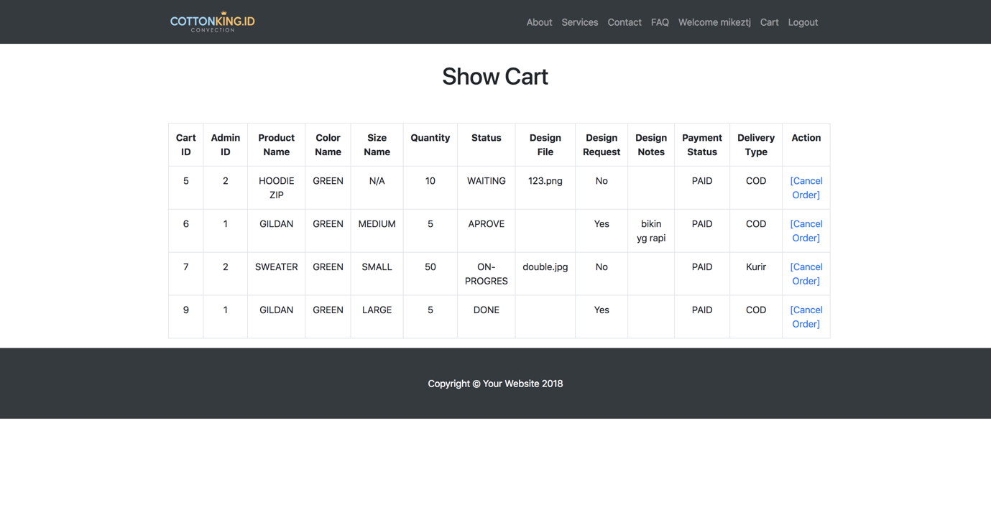

In the cart page customers are able to view their orders and also cancel an order if they think the order is wrong by clicking on the “Cancel Order” button.

* **About**

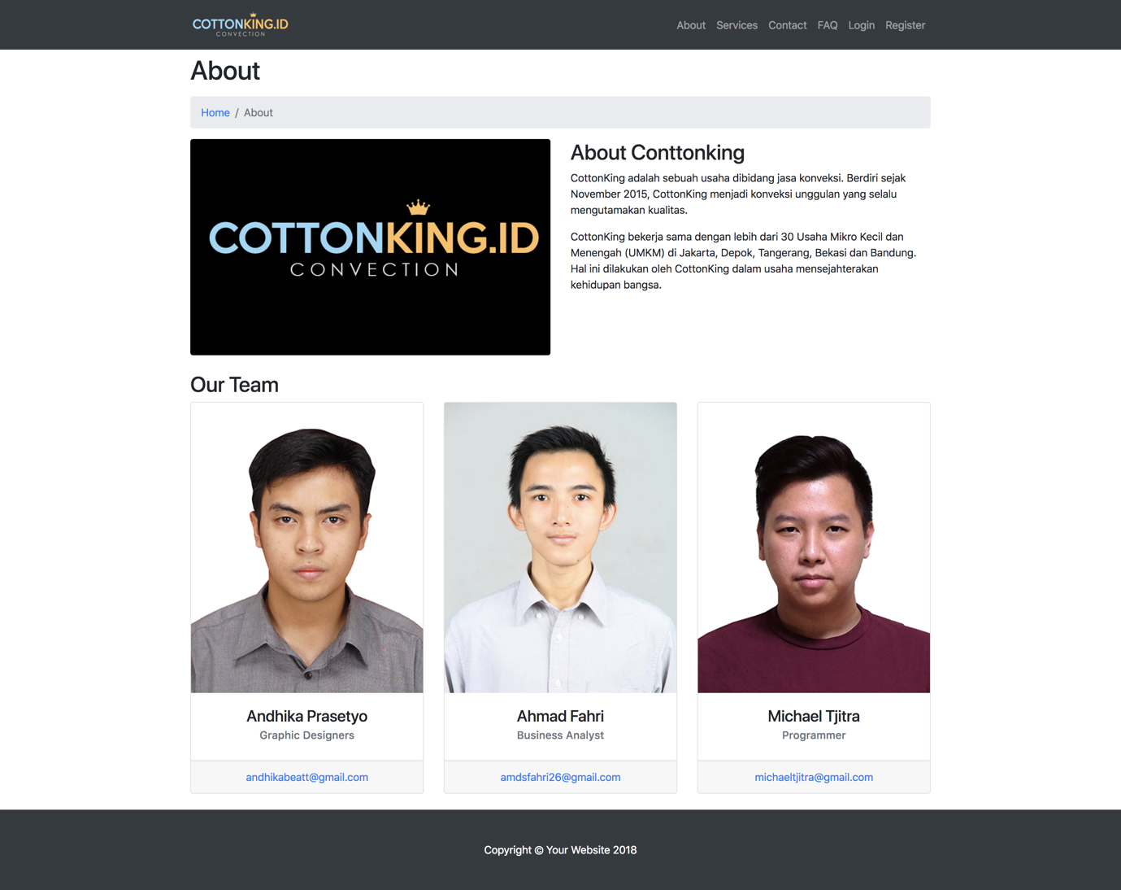

In this page customers can see the background of the company and how it is formed, also the teams behind the creation of the system. In this page customers are able to click on the email under the team members name if in some circumstances they wanted to contact one of them.

* **Contact**

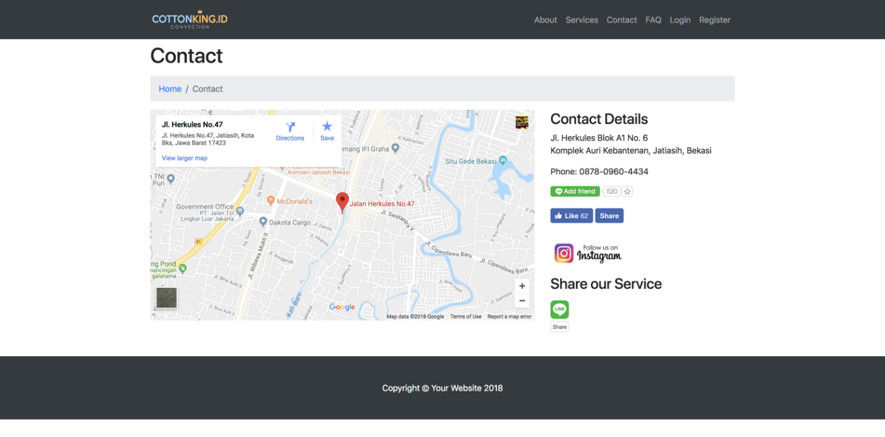

In the contact page customers are able to find informations about the company such as address to the physical store or office and how to contact the CottonKing business office, it also provides the CottonKing business social media channels. If the customers click on one of the button it will link them straight to the social media of the business. And if the customers wants to find the direction they can use the map “Get direction” service.

* **FAQ**

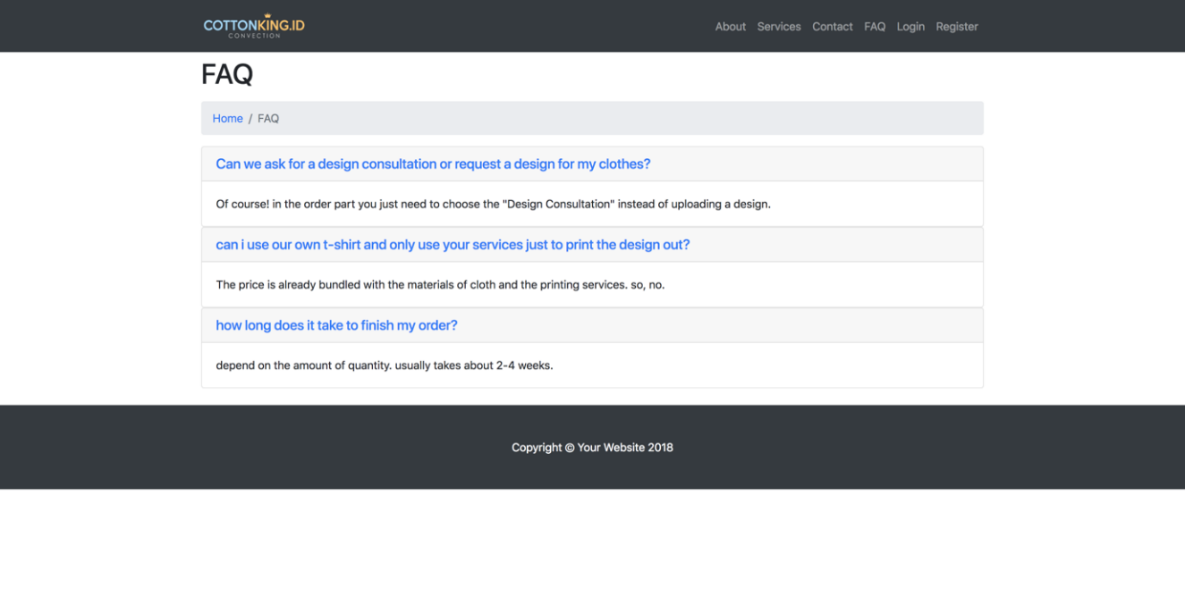

The FAQ (Frequently Asked Questions) page or UI is where the customers can find the questions that for them needed to be answered or explained. In this page the FAQ consist of several questions and answers regarding the process of buying and how to navigate in the website.

**User Interface Admin**

* **Home Page**

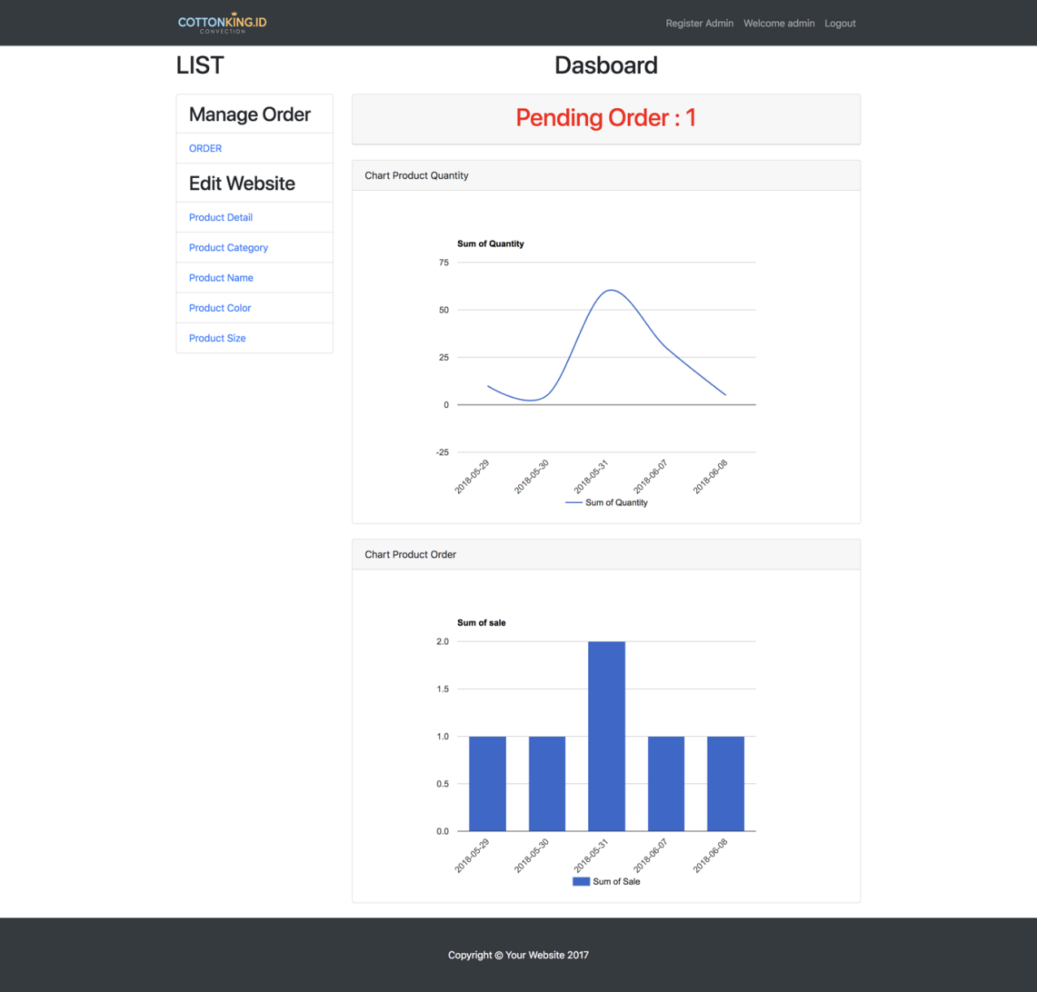

In this UI which is Homepage for admin is what the administrator will see or the administrator views when logged in with “admin” options. The Homepage is where the admin will navigate trough the services or features it needs to use to manage the CottonKing system such as orders and stocks. The Homepage itself contains several informations such as pending orders, product quantity, and orders statistics.

* **Show and Update Order**

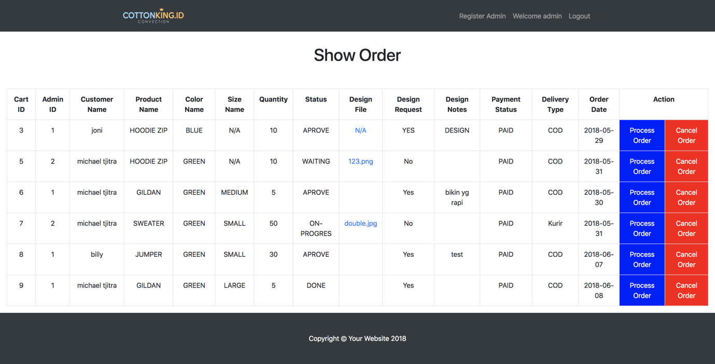

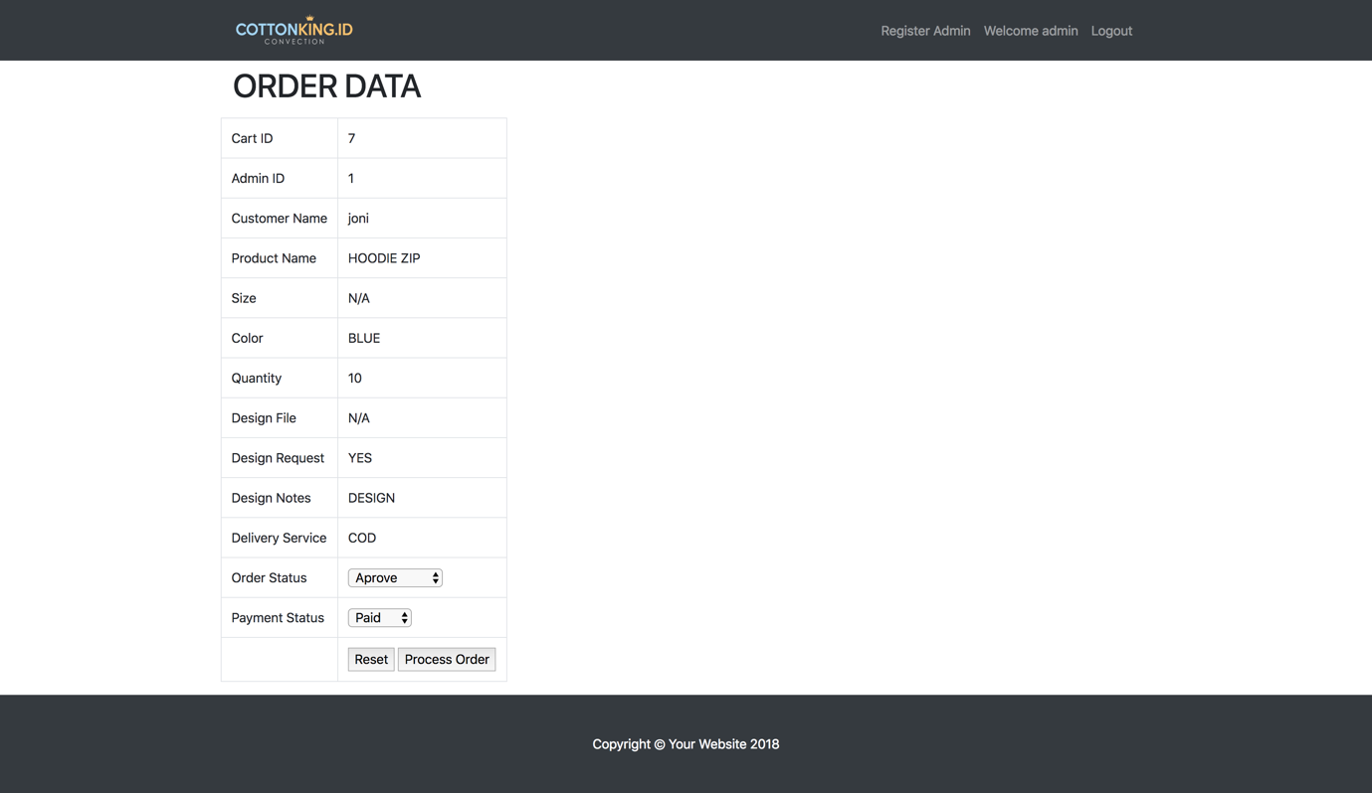

Both of the UI is about managing the orders coming to the system. Admin can process or cancel an order depending on the stocks or some circumstances. If the admin choose “process” the customers will get a notification saying that their orders are being processed, but if the admin choose “cancel” customers will get a notification that their orders are denied and a message to state the reason oh denying the orders. The bottom image is where the orders are accepted and the admin can edit the order status as well as the payment status of the order, every changes will be notified to the customers as well.

* **Insert and Show Product Name**

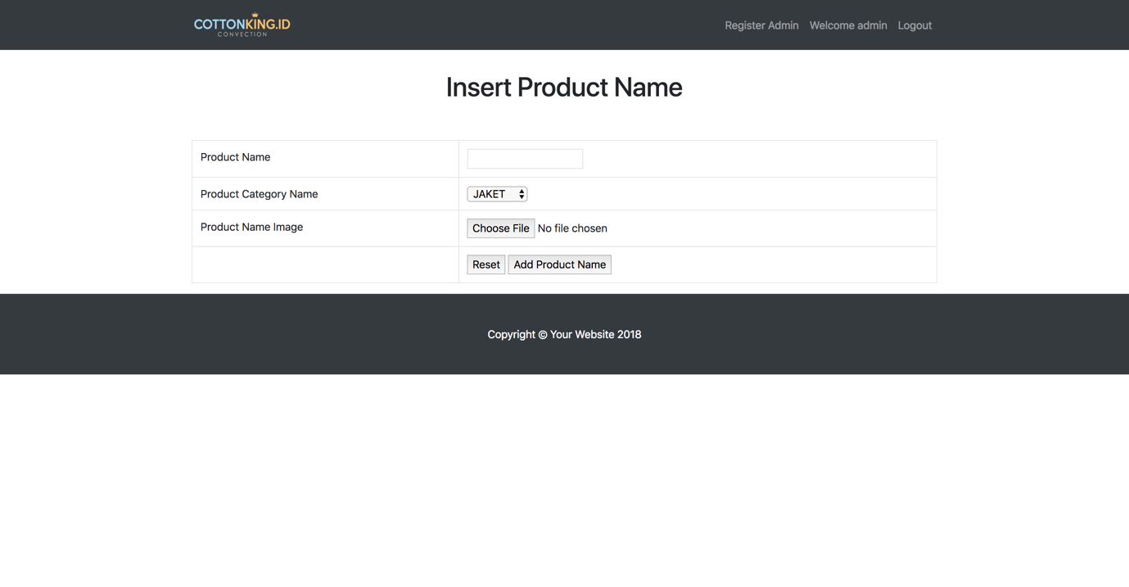

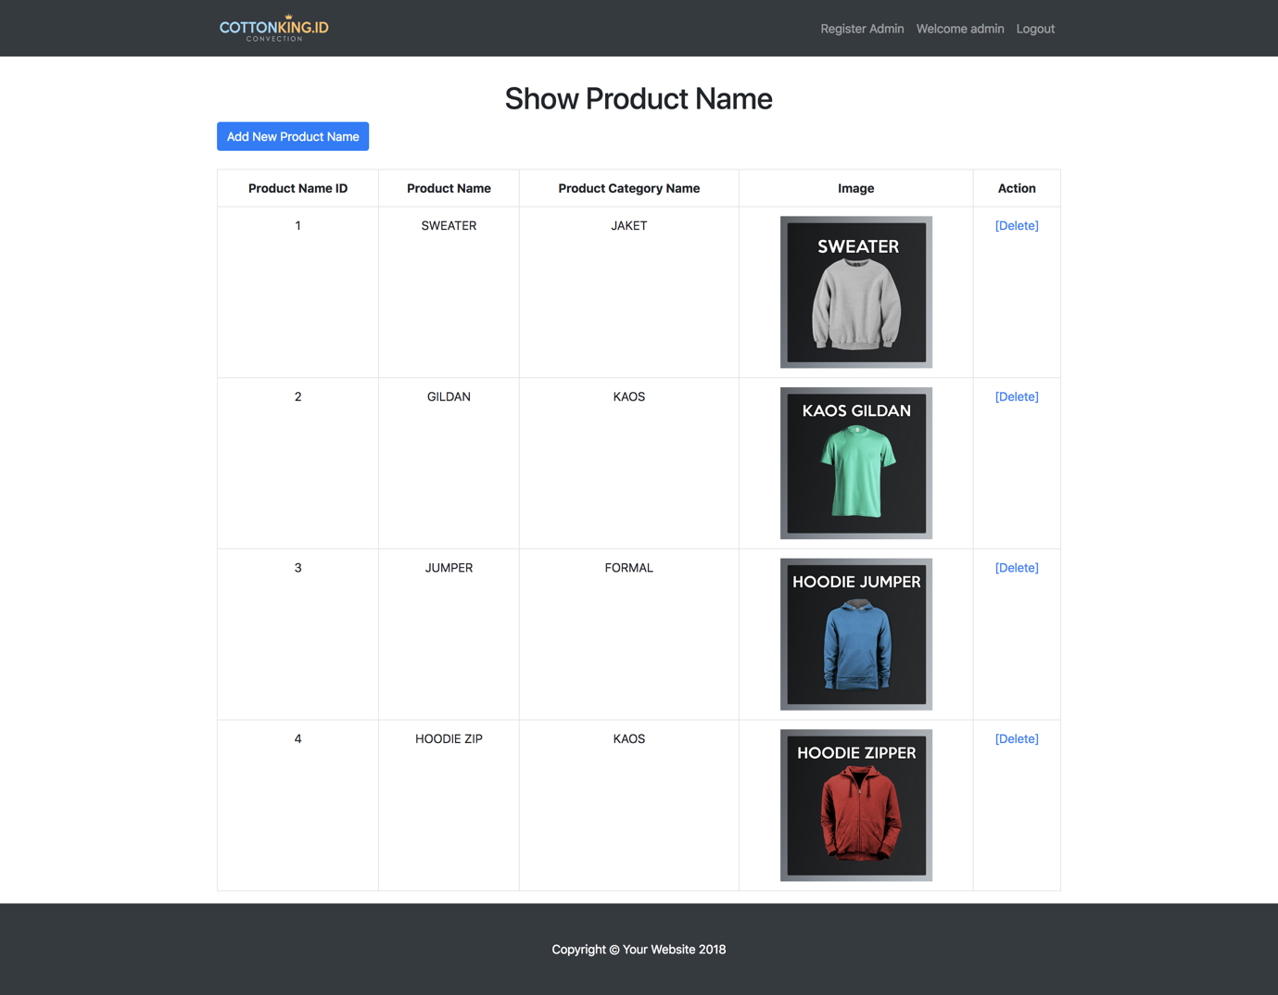

In this 2 page the purpose is to manage the products. Admin can add a new products by inserting product name, selecting the product category, and the product image. After that the admin can just click “Add product” to finish adding a new products. In the bottom image the admin can also shows the products based on the name an it will shows the id, name, category, and image of the product as well as options to delete an unnecessary product.

* **Insert and Show Product Detail**

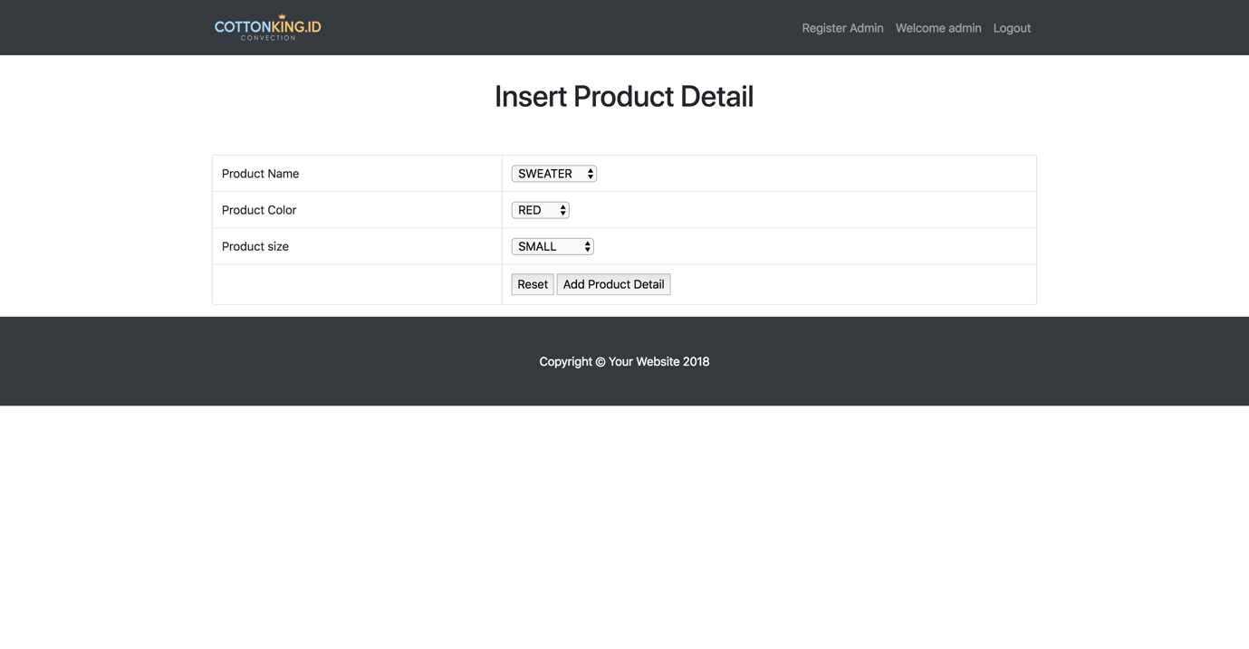

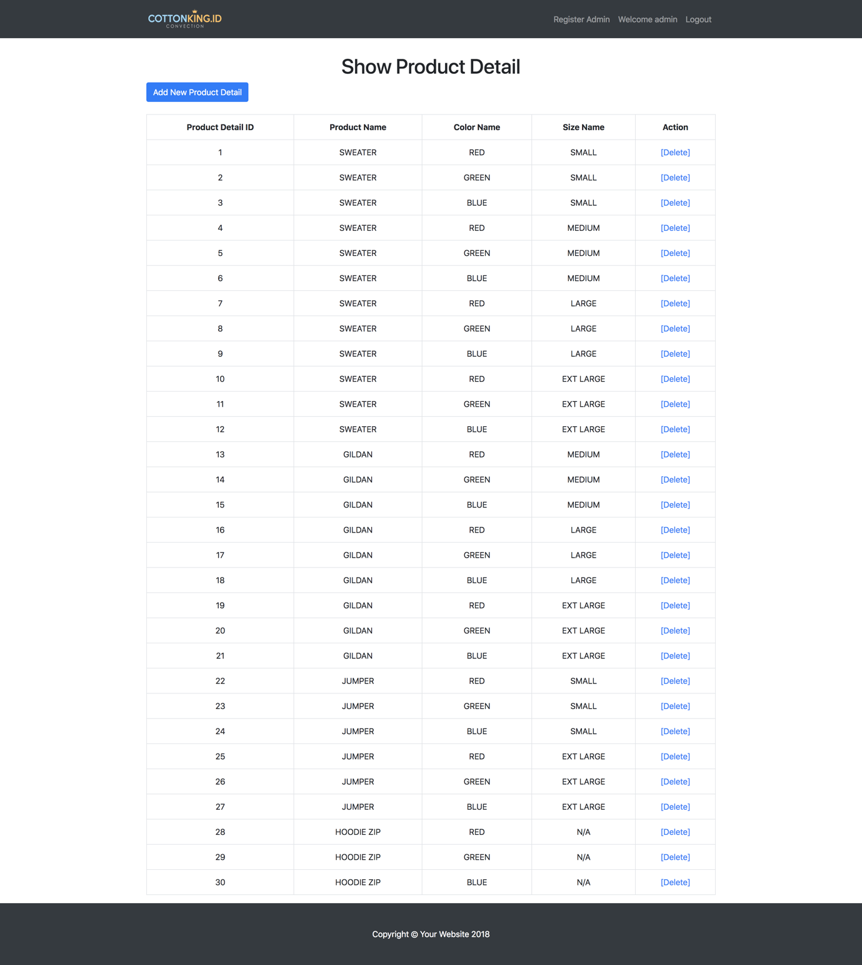

For the product detail page, the purpose is to add the existing products a detail information. The admin only need to choose the product name, available colours, and available sizes for the products. Admin can also see the list of the products and its details, not forgetting the options to delete an unnecessary data or detail.

* **Insert and Show Product Colour**

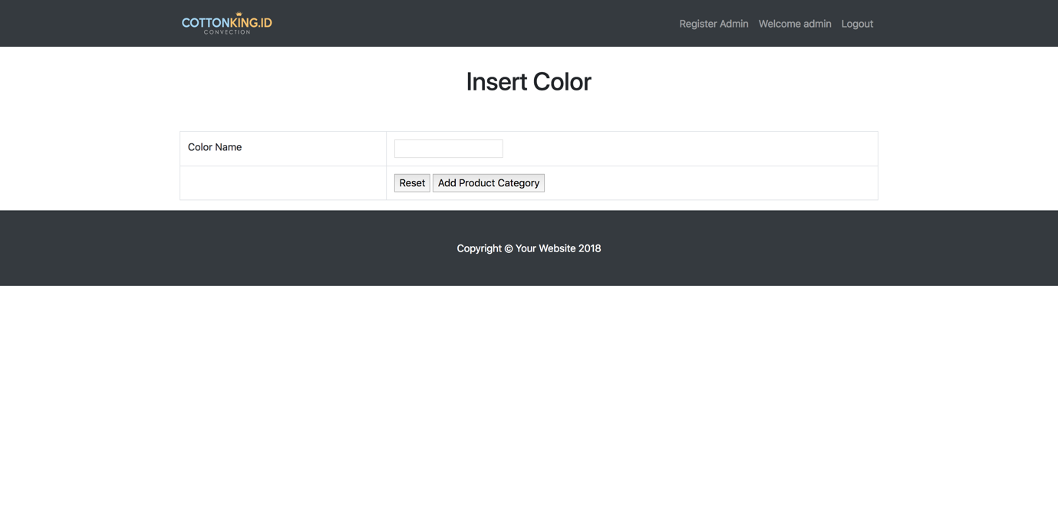

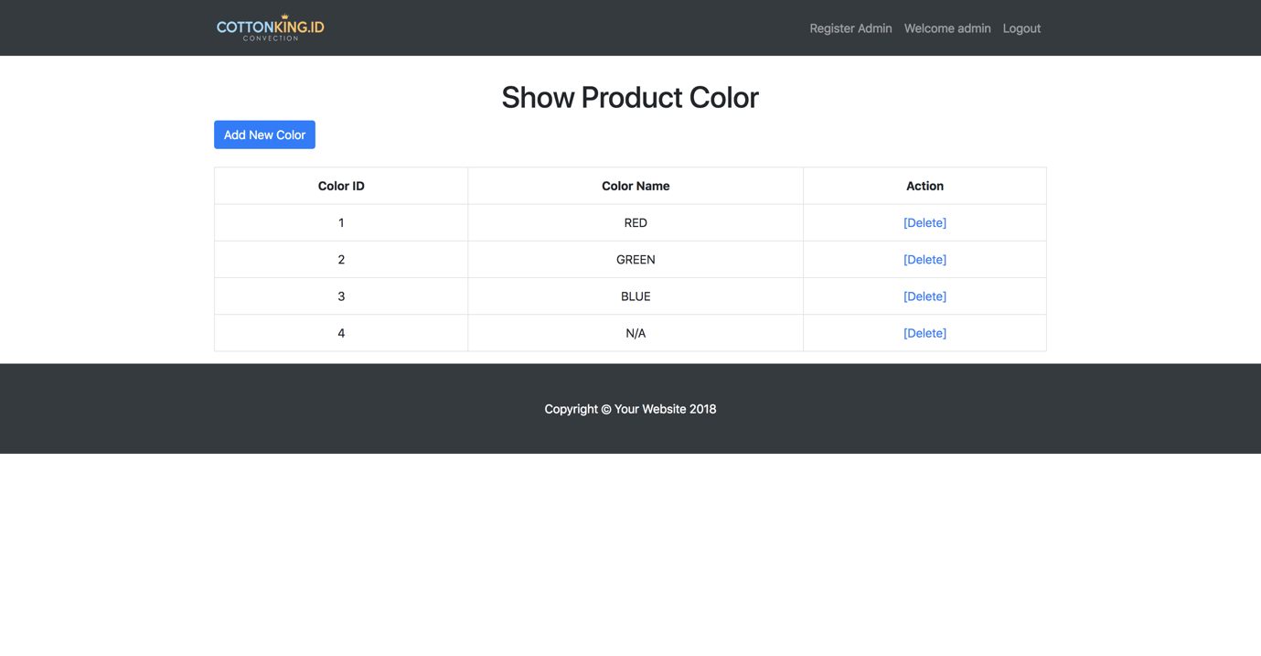

In this part admin can also add extra available colours into the system, by entering the colour data. And after that admin can see the list of the available colours in the system while having options to delete unnecessary colours.

* **Insert Size**

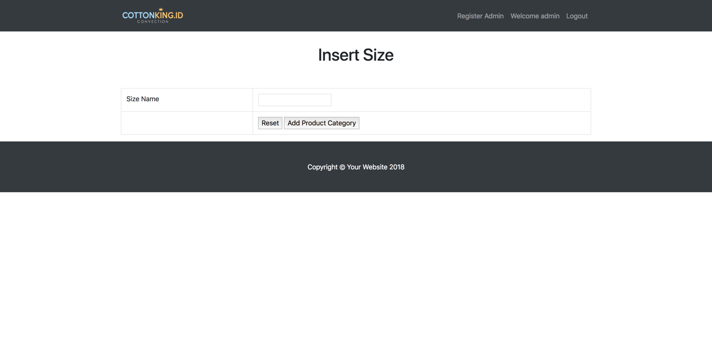

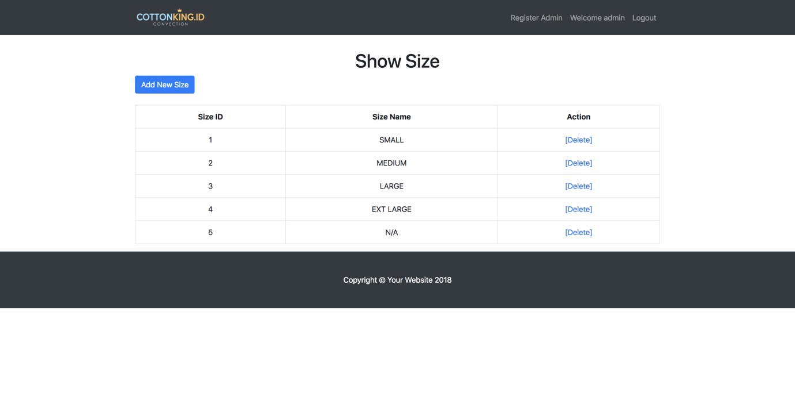

The insert and show available sizes page is one of the page that is used by the admin to add a new sizes available for the products or even deleting some sizes that are out of stocks or unavailable anymore.

* **Insert Product Category**

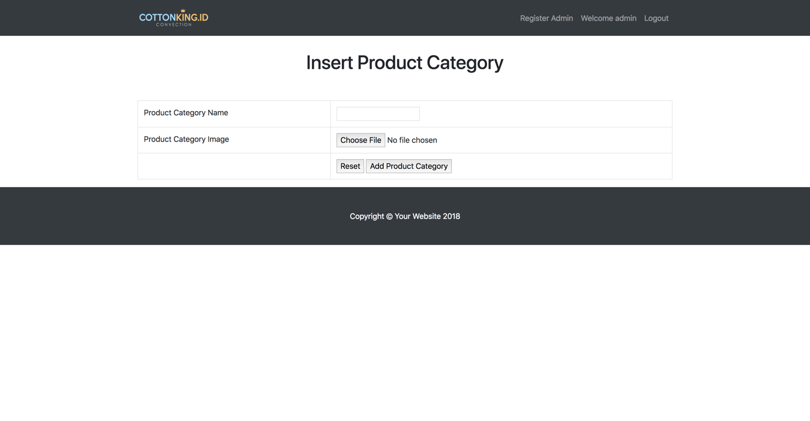

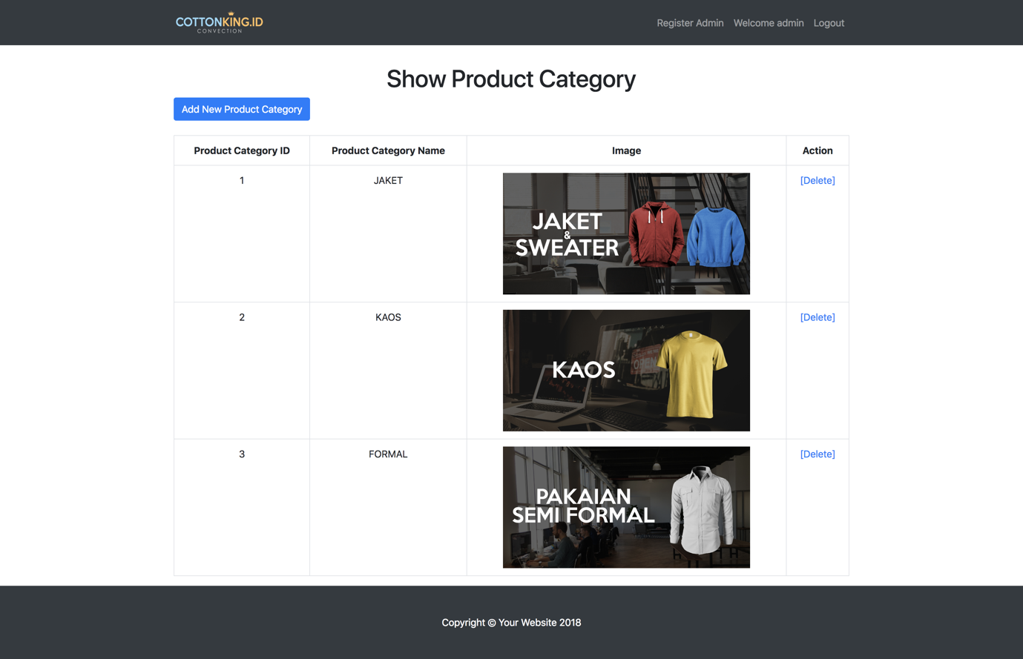

This is the Product Category page where the admins can manage the categories for the products in the system. The admin can also see the list of the available categories and can decide whether to delete the unnecessary categories or to create a new categories for the system. The admin just need to insert the required data such as categories name and the image for the categories.